A Project Report On
SUPER MARKET BILLING



Submitted By
DARSHIL KUMAR
Class: XII A

Under the Guidance of
Mr. Satpal Singh

Vanasthali Public School
A-461-462, Mayur Vihar Phase III, Delhi-110096

Contents

- Working Description
- Module Imported
- Coding
- Output
- Bibliography

Working Description
- To start the main program the User is asked about the Password which is the Password of SQL i.e. 123456(in this case)
- After this the program creates the database and the table for our program.
- Then the menu appears in which we can choose options for carrying out the mentioned operation.
- The User can view the products which are in the database(Supermarket) using the View Product Option(1).
- The user can also enter the information (Pno, PName, Brand, MRP, SellingP) of the product(Only If there is no entry with same Pno) in database using the Add product option(2).
- The user can also remove a record using Pno, PName or Brand of the product in database using the Remove product option(3).
- The user can also update the pno, name, brand, mrp, sellingp, of the any record using the Update Products option(4).
- The user can also search records which are in the Database by Modes(Pno,PName,Brand).If multiple records found it will show multiple using the Search Record option(5).
Module Imported

- mysql.connector
- To establish a connection between python(front end) and mysql(back end) and carry out the queries needed as per the program.
- datetime
- To capture system date and time and use it to display current date and time in the program.
- time
- To add some delay between parts of program

Coding
import mysql.connector as con
import datetime
import time
while True:
try:
pswd=input("Enter SQL Password:")
dbobj=con.connect(host="localhost",user="root",password=pswd,charset='utf8')
print("Connecting....")
time.sleep(2)
break
except :
print("***WRONG PASSWORD***")

crsr=dbobj.cursor()
now = datetime.datetime.now()

def dbtable():
crsr.execute("create database if not exists supermarket")
crsr.execute("use supermarket")
crsr.execute("create table if not exists product(PNO int,PNAME char(15),BRAND char(15),MRP int,SELLINGP int,primary key(PNO))")

def intro():
print()
print("_"*85)
print("""
DARSHIL SUPEMARKET {}

0)EXIT
1)VIEW PRODUCTS
2)ADD PRODUCT
3)REMOVE PRODUCT
4)UPDATE PRODUCTS
5)SEARCH RECORD
""".format(now.strftime('%d-%m-%Y %H:%M')))

def intinp(stmnt):
y=0
while y==0:
try:
x=input(stmnt)
if bool(int(x))==True:
y=1
return int(x)
except:
print("****Integer Value Required****")

def searchby():
print("SEARCH PRODUCT".center(85,'='))
print("""
MODES:
0)EXIT
1)PNO
2)PNAME
3)BRAND """)
print("_"*85)
y=0
data=""
while y==0:
try:
print()
mod=input("Enter Mode:")
if mod=="0":
y=1
break
elif mod=="1" or mod=="pno" or mod=="PNO":
z=1
while z==1:
try:
val=intinp("Enter PNO")
if val==0:
z=0
else:
searchrecord("pno",val)
z=0
except:
print("_____Wrong values_____")
elif mod=="2" or mod=="PNAME" or mod=="pname":
z=1
while z==1:
try:
data=input("Enter PNAME:")
if data=="0":
z=1
else:
z=0
searchrecord("pname",data)
except:
print("_____Wrong values_____")
elif mod=="3" or mod=="BRAND" or mod=="brand":
z=1
while z==1:
try:
data=input("Enter BRAND:")
if data=="0":
z=1
else:
z=0
searchrecord("brand",data)
except:
print("_____Wrong values_____")
else:
print("WRONG MODE SELECTED...")
except ValueError:
print("_____Wrong values_____")

def searchrecord(by,val):
try:
crsr.execute("select * from product where {}='{}'".format(by,val))
data=crsr.fetchall()
if data==[]:
print("EMPTY RECORD")
else:
crsr.execute("desc product;")
recs=crsr.fetchall()
print(recs[0][0].ljust(7),recs[1][0].ljust(25),recs[2][0].ljust(25),recs[3][0].ljust(10),recs[4][0].ljust(10),sep="")
for rec in data:
print(str(rec[0]).ljust(7),rec[1].ljust(25),rec[2].ljust(25),str(rec[3]).ljust(10),str(rec[4]).ljust(10),sep="")
except Exception as error:
print("_____Wrong values_____",error)

def viewproduct():
print()
print("-"*85)
crsr.execute("desc product;")
recs=crsr.fetchall()
print(recs[0][0].ljust(7),recs[1][0].ljust(25),recs[2][0].ljust(25),recs[3][0].ljust(10),recs[4][0].ljust(10),sep="")
crsr.execute("select * from product;")
recs=crsr.fetchall()
for rec in recs:
print(str(rec[0]).ljust(7),rec[1].ljust(25),rec[2].ljust(25),str(rec[3]).ljust(10),str(rec[4]).ljust(10),sep="")

def addproduct():
print("ADD PRODUCT".center(85,'='))
try:
n=intinp("Enter no. of records to be added:")
for w in range (n):
try:
pno=intinp("Enter PNO:")
pname=input("Enter PNAME:")
brand=input("Enter BRAND:")
mrp=intinp("Enter MRP:")
sellingp=intinp("Enter SELLINGP:")
record=(str(pno),pname,brand,str(mrp),str(sellingp))
print(record)
print()
confirm=input("Confirm(y/n):")
print()
try:
if confirm=="y" or confirm=="Y":
crsr.execute("insert into product values {}".format(record))
crsr.execute("commit")
print()
except con.errors.IntegrityError:
print("****DUPLICATE KEY NOT ALLOWED****")
except con.errors.DataError:
print("DATA TOO LONG")
except ValueError:
print("_____Wrong values_____")
except ValueError:
print("_____Wrong values_____")

def remove(by,val):
try:
crsr.execute("select * from product where {}='{}'".format(by,val))
rec=crsr.fetchall()
if rec==[]:
print("EMPTY RECORD")
else:
print("Record:")
print(rec)
confirm=input("Confirm(y/n):")
if confirm=="y" or confirm=="Y":
if by=="pno":
crsr.execute("delete from product where pno ={}".format(val))
elif by=="pname":
crsr.execute("delete from product where pname = '{}'".format(val))
elif by=="brand":
crsr.execute("delete from product where brand ='{}'".format(val))
crsr.execute("commit")
print("RECORD DELETED")
return
else:
pass
except:
print("_____Wrong values_____")

def removeproduct():
print("REMOVE PRODUCT".center(85,'='))
print("""
MODES:
0)EXIT
1)PNO
2)PNAME
3)BRAND """)
print("_"*85)
y=0
data=""
while y==0:
try:
print()
mod=input("Enter Mode:")
if mod=="0":
y=1
break
elif mod=="1" or mod=="pno" or mod=="PNO":
z=1
while z==1:
try:
val=intinp("Enter PNO")
if val==0:
z=0
else:
remove("pno",val)
z=0
except:
print("_____Wrong values_____")
elif mod=="2" or mod=="PNAME" or mod=="pname":
z=1
while z==1:
try:
data=input("Enter PNAME:")
if data=="0":
z=1
else:
z=0
remove("pname",data)
except:
print("_____Wrong values_____")
elif mod=="3" or mod=="BRAND" or mod=="brand":
z=1
while z==1:
try:
data=input("Enter BRAND:")
if data=="0":
z=1
else:
z=0
remove("brand",data)
except:
print("_____Wrong values_____")
else:
print("WRONG MODE SELECTED...")
except ValueError:
print("_____Wrong values_____")

def update(mod,val):
try:
crsr.execute("select * from product where {}='{}'".format(mod,val))
rec=crsr.fetchall()
if rec==None:
print("EMPTY RECORD")
else:
print("Record:")
print(rec)
confirm=input("Confirm(y/n):")
if confirm=="y" or confirm=="Y":
if mod=="pno":
newrec=intinp("Enter NEW PNO:")
crsr.execute("update product set pno={} where pno={}".format(newrec,val))
elif mod=="pname":
newrec=input("Enter NEW PNAME:")
k="update product set pname= '"+ newrec+"' where pname= '"+val + "'"
crsr.execute(k)
elif mod=="brand":
newrec=input("Enter NEW BRAND:")
k="update product set brand= '"+ newrec+"' where brand= '"+val + "'"
crsr.execute(k)
elif mod=="mrp":
newrec=intinp("Enter NEW MRP:")
crsr.execute("update product set mrp={} where mrp={}".format(newrec,val))
elif mod=="sellingp":
newrec=intinp("Enter NEW SELLINGP:")
crsr.execute("update product set sellingp={} where sellingp={}".format(newrec,val))
crsr.execute("commit")
print("RECORD UPDATED")
return
else:
pass
except:
print("_____Wrong values_____")

def updateproduct():
print("UPDATE PRODUCT".center(85,'='))
print("""
0)EXIT
1)PNO
2)PNAME
3)BRAND
4)MRP
5)SELLINGP
""")
y=0
data=""
while y==0:
try:
print()
mod=input("Enter Mode:")
if mod=="0":
y=1
break
elif mod=="1" or mod=="pno" or mod=="PNO":
z=1
while z==1:
try:
val=intinp("Enter CURRENT PNO: ")
if val==0:
z=0
else:
update("pno",val)
z=0
except:
print("_____Wrong values_____")
elif mod=="2" or mod=="PNAME" or mod=="pname":
z=1
while z==1:
try:
data=input("Enter PNAME:")
if data=="0":
z=1
else:
z=0
update("pname",data)
except:
print("_____Wrong values_____")
elif mod=="3" or mod=="BRAND" or mod=="brand":
z=1
while z==1:
try:
data=input("Enter BRAND:")
if data=="0":
z=1
else:
z=0
update("brand",data)
except:
print("_____Wrong values_____")
elif mod=="4" or mod=="MRP" or mod=="mrp":
z=1
while z==1:
try:
data=intinp("Enter CURRENT MRP:")
if data=="0":
z=1
else:
z=0
update("mrp",data)
except:
print("_____Wrong values_____")
elif mod=="5" or mod=="SELLINGP" or mod=="sellingp":
z=1
while z==1:
try:
data=intinp("Enter CURRENT SELLINGP:")
if data=="0":
z=1
else:
z=0
update("sellingp",data)
except:
print("_____Wrong values_____")
else:
print("WRONG MODE SELECTED...")
except ValueError:
print("_____Wrong values_____")

def main():
dbtable()
while True:
time.sleep(1)
intro()
option=input("Enter Option:")
if option=="1":
viewproduct()
elif option=="2":
addproduct()
elif option=="3":
removeproduct()
elif option=="4":
updateproduct()
elif option=="5":
searchby()
elif option=="0":
print("Thanks for visiting...")
break
else:
print("Try Again")
main()

Output
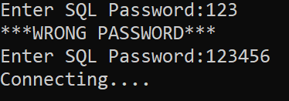
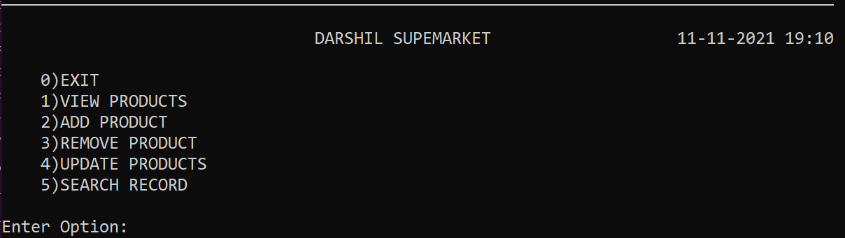

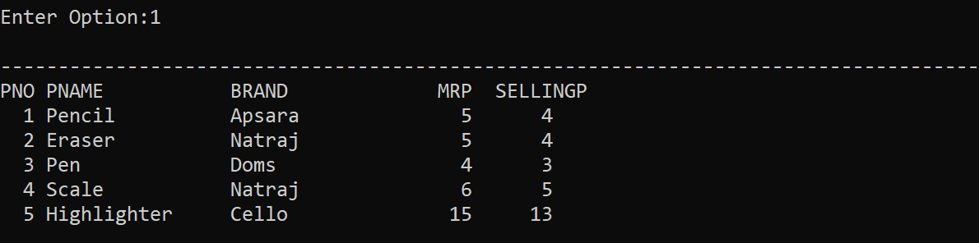

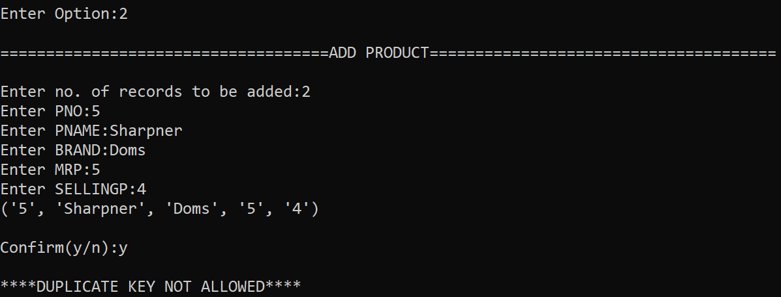
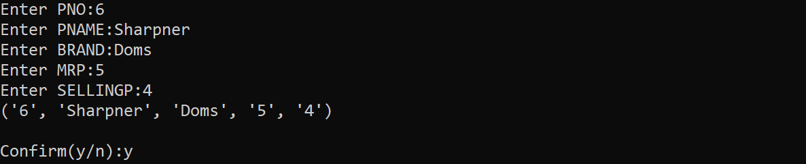
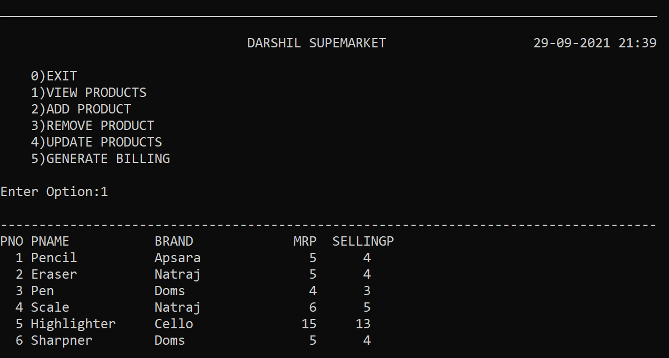

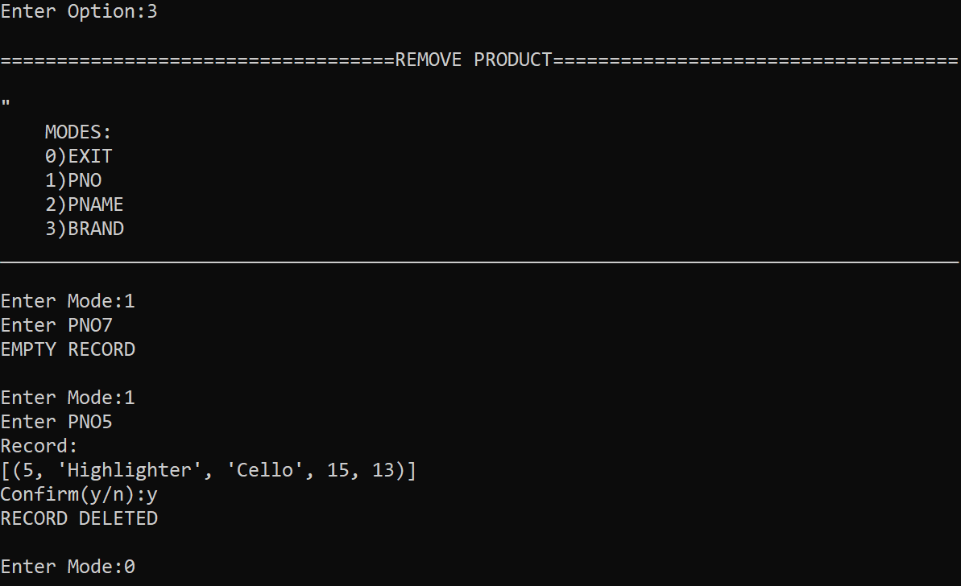
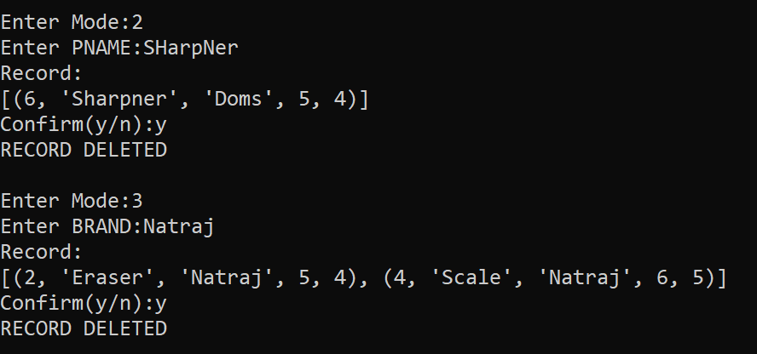
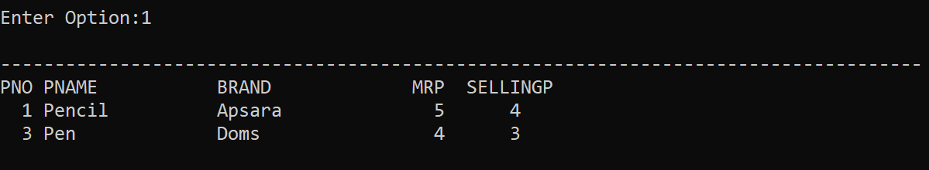
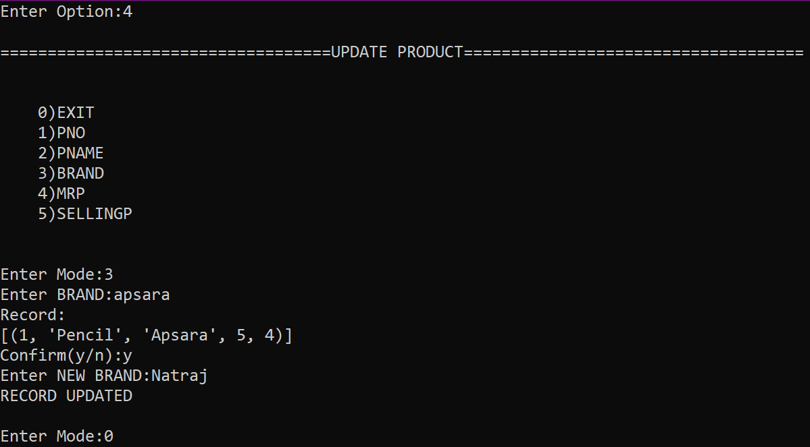
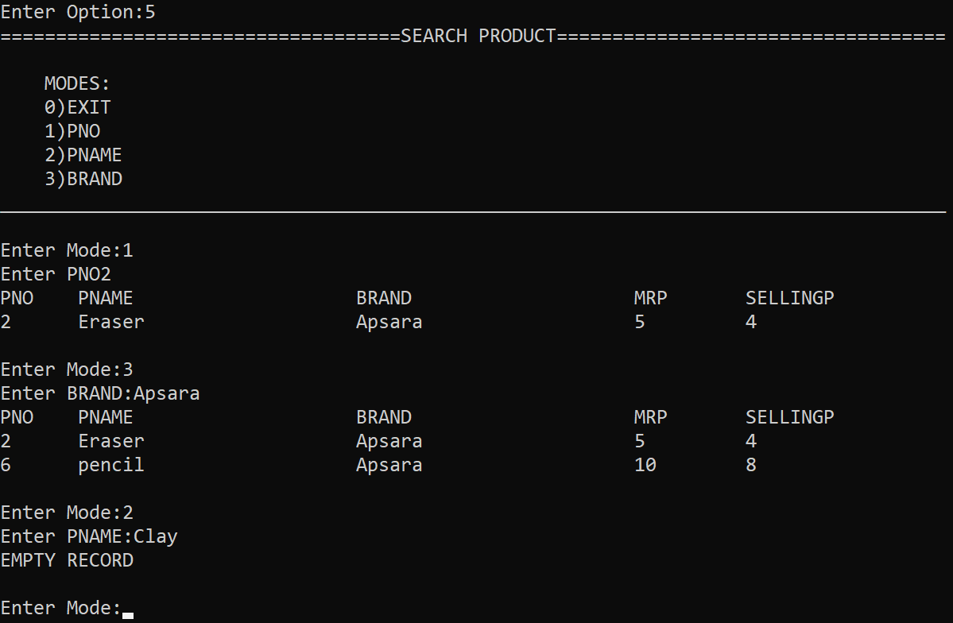

Bibliography
http://www.google.com/
https://www.w3schools.com/
https://www.geeksforgeeks.org/
Computer Science with Python by Sumita Arora

